1. **Write a C program to search a number using Linear Search method.**

**PROGRAM:**

#include <stdio.h>

int linearSearch(int arr[], int n, int key) {

for (int i = 0; i < n; i++) {

if (arr[i] == key) {

return i;

}}

return -1;

}

int main() {

int arr[] = {2, 5, 7, 9, 11, 13, 17};

int n = sizeof(arr) / sizeof(arr[0]);

int key = 11;

int result = linearSearch(arr, n, key);

if (result == -1) {

printf("Element not found\n");

} else {

printf("Element found at index: %d\n", result);

}

return 0;

}

**INPUT:**

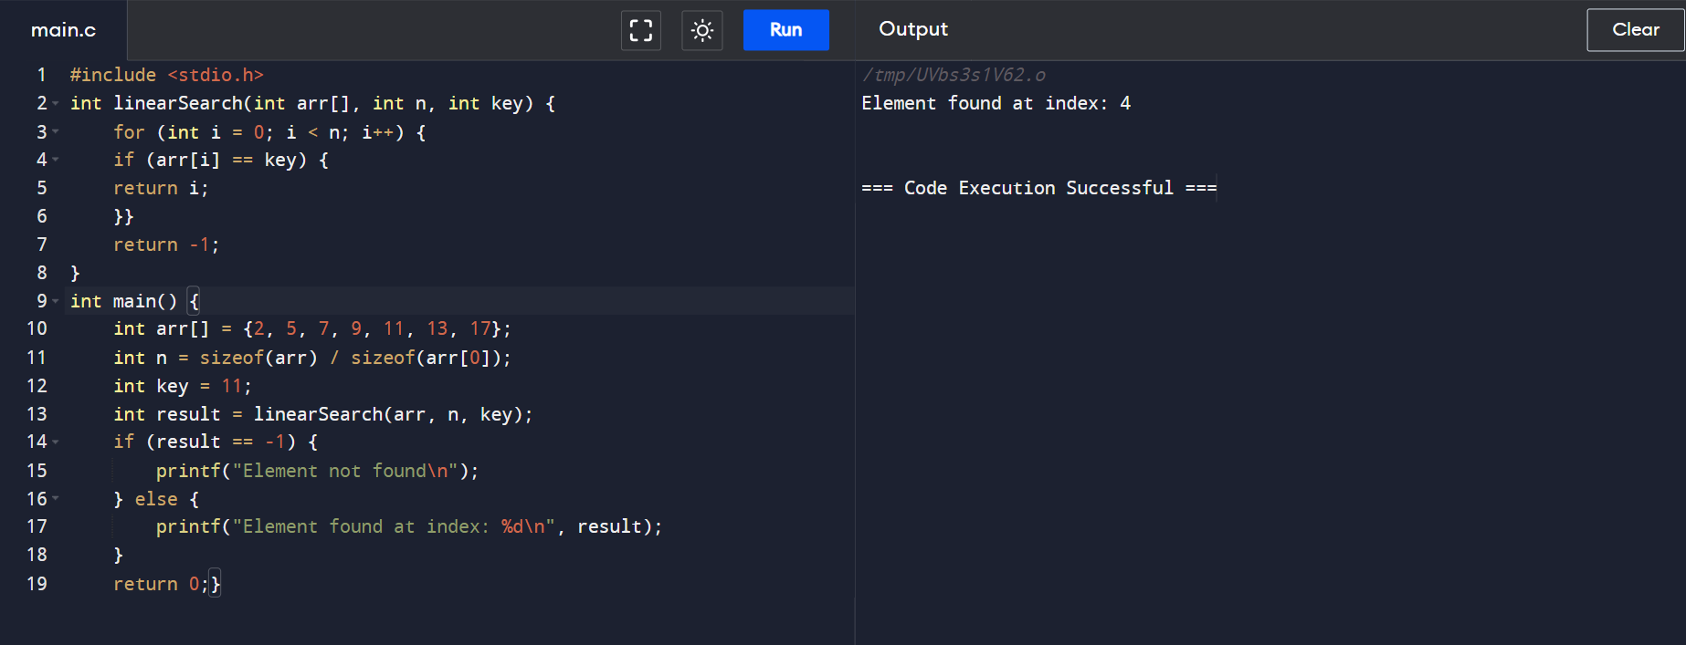

**OUTPUT:**

